**Beginners:**

***Lesson 1***

* Log into Kali using Root and toor
  + Explain what root is: like admin
* Find Kali’s version of File Explorer and explore the files
  + Don’t open anything just look at file names
  + See how far back you can get into the files
  + Find Root file
  + What is in the root file?
  + Root is a user, like an admin. It’s the user with the most privileges. Just like in Windows, all of the files (Desktop, Documents, etc.) are under that user’s name.
* Find the Following:
  + Settings
  + Desktop Background
    - Change it to one of the pre-installed ones
  + Mousepad
    - Open
    - Write hello world!
    - Name it hello and Save it to your Documents folder
    - Exit
* Explore Kali
  + What happens when you click on the tools?
    - Most of them pull up a terminal
    - Kali is mostly used via a terminal
    - Windows has more GUI than Linux
      * What’s a GUI?
      * [Graphical User Interface Examples (conceptdraw.com)](https://www.conceptdraw.com/How-To-Guide/graphical-user-interface-examples)
      * All the nice windows that pop up when you click on an application
      * When you click on the file system, that’s a gui
      * You have visuals to see what you’re doing
      * Since Linux is mostly Terminal, how do we go through the file system without a GUI?
* Teach how to navigate that same file system but in a terminal
  + Terminals don’t work like google
  + They use commands to work
  + Commands to Tech for File Navigation:
    - Pwd: tells you where you are
      * Remember how the user’s files are under the users name? We can still find those files and see them in the terminal
    - ls : to see the files of the path you are in
      * Go over file path if needed
      * All of the things in blue are directories
        + Those are the other folders that we can move to
        + What folder is the hello in? Documents
        + How do we get there?
    - Cd: change directory
      * cd Documents
      * LINUX IS CASE SENSITIVE
      * Assume everything is lowercase unless you see otherwise, like a file or directory name
      * Ls again, list the files
      * You should see hello
      * How do we read what it says?
    - Cat: will read the file
      * Do cat hello
      * Congrats you did it!
* Extra Linux Rules:
  + Case Sensitive
  + You have to specify a path like /root/Documents or go into the documents folder to see anything in there
  + If you accidentally run something you arent supposed to use Ctrl+C end it

***Lesson 2***

* File Permissions
  + You can only access a File if you have permission to see it
  + As root, you can see or change anything you want
  + Not that you should, but you have the ability to
  + So how do you see file permissions
* Find the hello Mousepad again
  + Right click on it
  + Click properties
  + Click Permissions
  + You can see the owner, the owner’s group, and others who can see the file
    - It also specifies the access they have to that file (Read, Read & Write, etc.)
* Now check for file permissions in a Terminal
  + Open a terminal
  + Use ls --help
    - The - is a switch that gives the command more specifics
    - --help will pull up a menu that shows all of your options
    - There are two that will help in this case
      * -a : shows all files, even hidden ones
        + Yes there are hidden folders, Windows has those too
      * -l : long listing format meaning more information
      * You can combine them both together so instead of using ls -l -a it’s ls -la
    - This gives you the
      * file permissions
      * the owner (creator) of the file
      * the group to which that owner belongs to
      * the date of creation
      * [Linux File Permissions Tutorial: How to View and Change Permission (phoenixnap.com)](https://phoenixnap.com/kb/linux-file-permissions)
      * 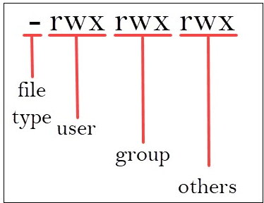
        + The file type can be a -, d, or i: file, directory, or link
        + Rwx means read, write, execute
        + Those are the 3 permissions on Linux
  + Look at hello
  + What does it say for the permissions?
    - -rw-r--r--
    - - means it is a file
    - The first rw- means the user can read and write or modify it, no execute
    - R-- means the group can only read it
    - R-- means others can only read it
    - The next two words are the owner and group

***Lesson 3***

* Changing file permissions
  + The command for that: chmod
  + You type chmod [permission] [file_name]
    - You can only do this if you have the permission to do so
    - Since you are root, it’s allowed
  + You have to specify the permissions for each section. For example:
    - chmod u=rwx,g=rwx o=rwx hello (if you’re in Documents)
      * No spaces, no capitals
    - You just changed file permissions to read write and execute for the user, group, and owner of hello
    - Go ahead and ls -la again
    - Now hello should say -rwxrwxrwx
    - Try and use the chmod commands to set the permissions back to normal
      * Make the user allowed to read and write
      * Make the members allowed to read
      * Makes others allowed to read
    - 5 Min Later
      * Should be chmod u=rw,g=r,o=r hello
* Instead of letters, the octal format represents privileges with numbers:
  + r(ead) has the value of 4
  + w(rite) has the value of 2
  + (e)x(ecute) has the value of 1
  + no permission has the value of 0
* The privileges are summed up and depicted by one number. Therefore, the possibilities are:
  + 7 – for read, write, and execute permission
  + 6 – for read and write privileges
  + 5 – for read and execute privileges
  + 4 – for read privileges
* As you have to define permission for each category (user, group, owner), the command will include three (3) numbers (each representing the summation of privileges).
  + chmod u=rw,g=r,o=r hello command.
  + chmod 644 hello
* At some point cd . and cd ..
  + Explain what . and .. is
* More commands: mkdir, rm, touch, --help and man (manual), cp filename filepath, mv to rename or mv filename filepath, and locate

**Intermediate:**

***Lesson 1***

* echo and cat
  + 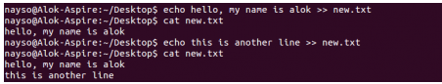
* nano hello.txt
* sudo apt update
  + Sudo just runs the command with root privileges so this would work without sudo if you were logged in as root as well
* df
  + Shows available disk spaces
  + Can use -m to show in megabytes
* zip and unzip
  + zip and unzip hello
* chmod
  + You can add individual permissions by using +r, +w, or +x to a file
* hostname
  + Prints host name
  + hostname -i gives you your ip address
* ping google.com or 8.8.8.8

***Lesson 2***

* What does rm -rf / do?
  + Removes with all directories and their contents with force
  + DONT DO IT
  + But what is /?
    - / means the root directory
    - Which is everything, it holds all the files and directories

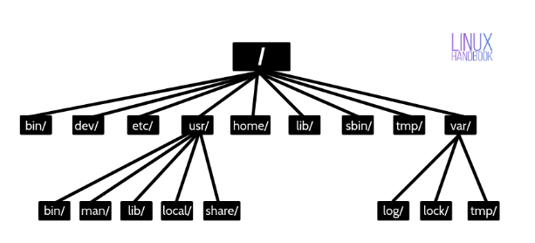

* Go back to the Documents folder
  + Pwd and tell me where you are
  + /root/Downloads : / means look at the very tippy top of the directory and follow the path from there
  + Don’t get root directory confused with the root user, those are two different things
* Open /bin (Binaries)
  + See anything familiar?
  + It holds the executables of a lot of commands
  + It has ls, chmod, and more
  + This means that commands are just executables that we are calling to
  + [Linux Directory Structure Explained for Beginners (linuxhandbook.com)](https://linuxhandbook.com/linux-directory-structure/)

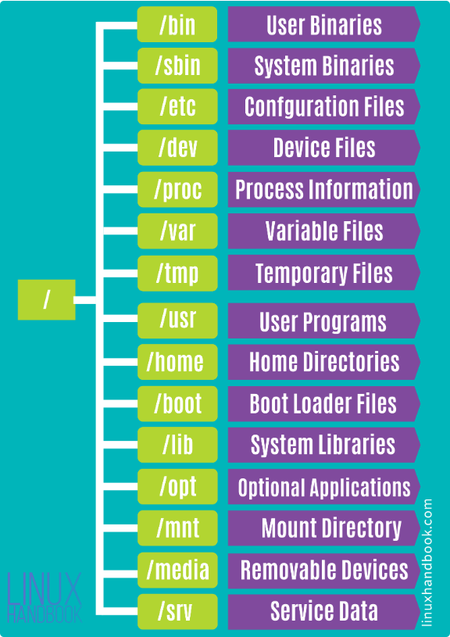

**Advanced:**

* Ifconfig
* netdiscover
* Nmap
* Recon-ng
* CyberChef
* Learn how to hash
  + Then hash cat or jtr
* Wireshark
* Digital Forensics:
  + Autopsy
  + FTK Imager
  + CSI Linux
  + Volatility